Jenkins-assignment 11:
Build and package LoginWebApp .war file on slave and deploy on slave only
------------------------------------------------------------------------------------------------------------------
Jenkins Master and slave Launch and configured
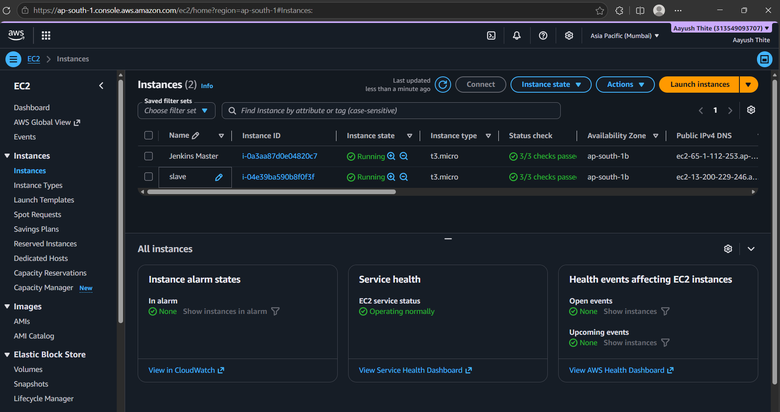
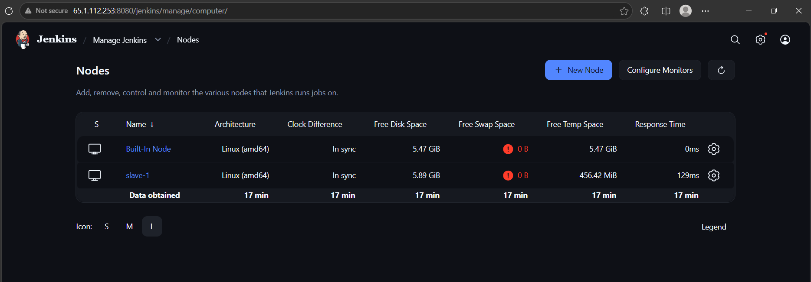
Java-21 and Git manually installed on Slave machine. Also, with the help of Jenkins tools integrated Maven’s latest version which we will use to compile and package .war on slave
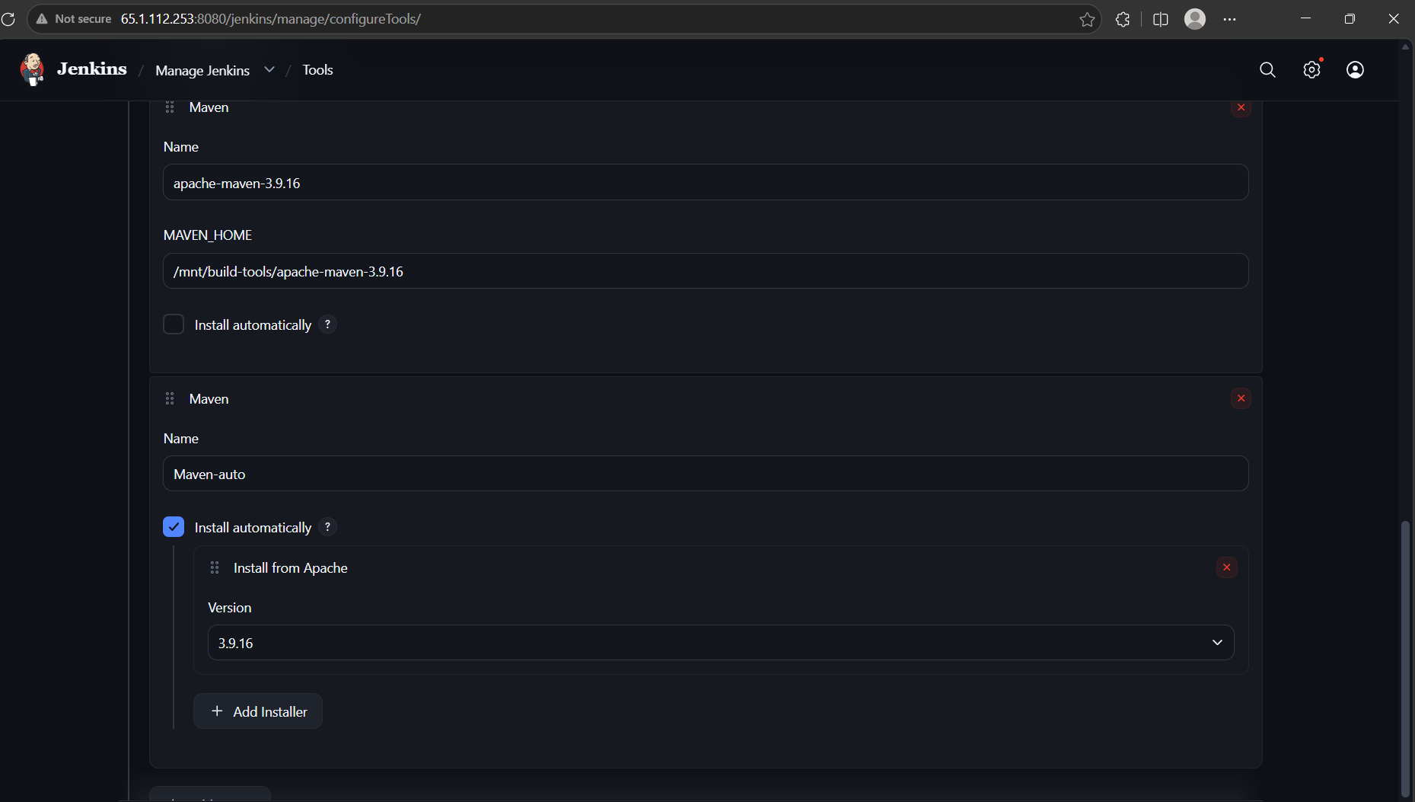
Now will configure job which will get build on slave
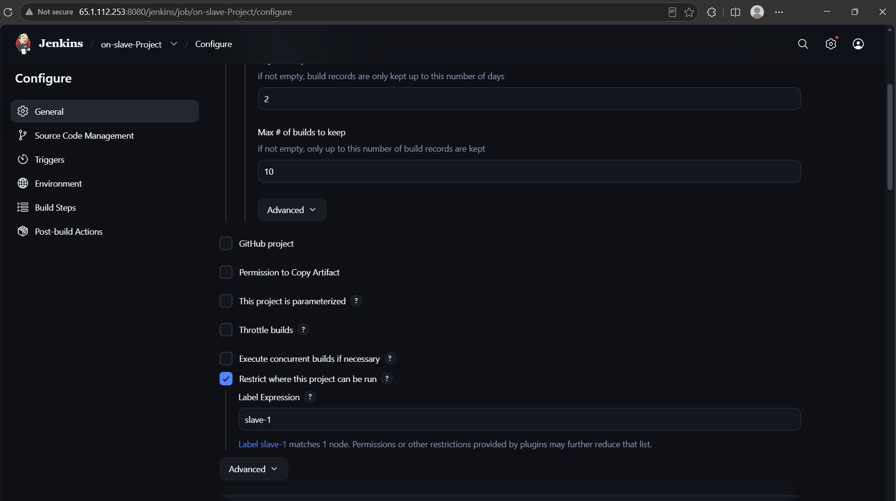

Cloning repository
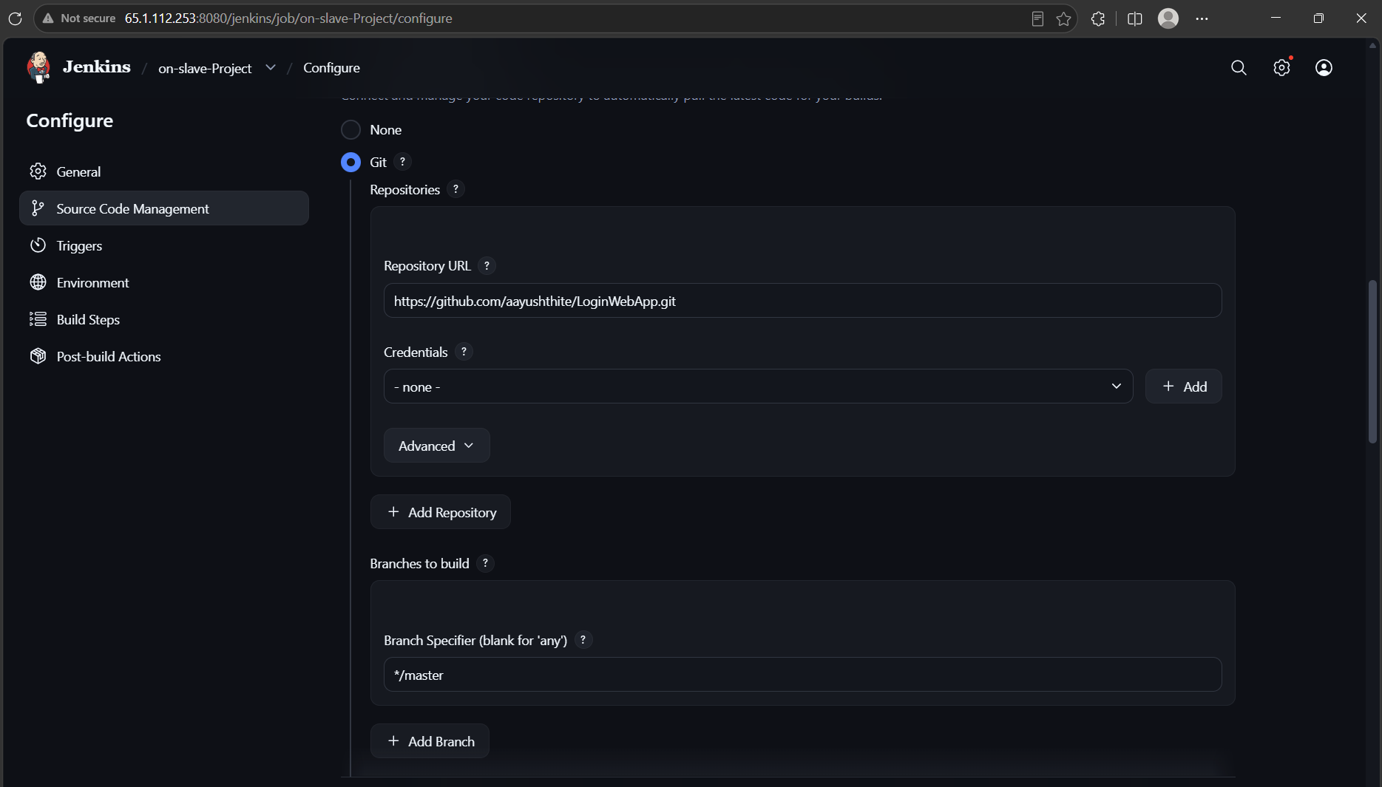
After the .war file build copying file into tomcat/webapps folder which is already installed on slave
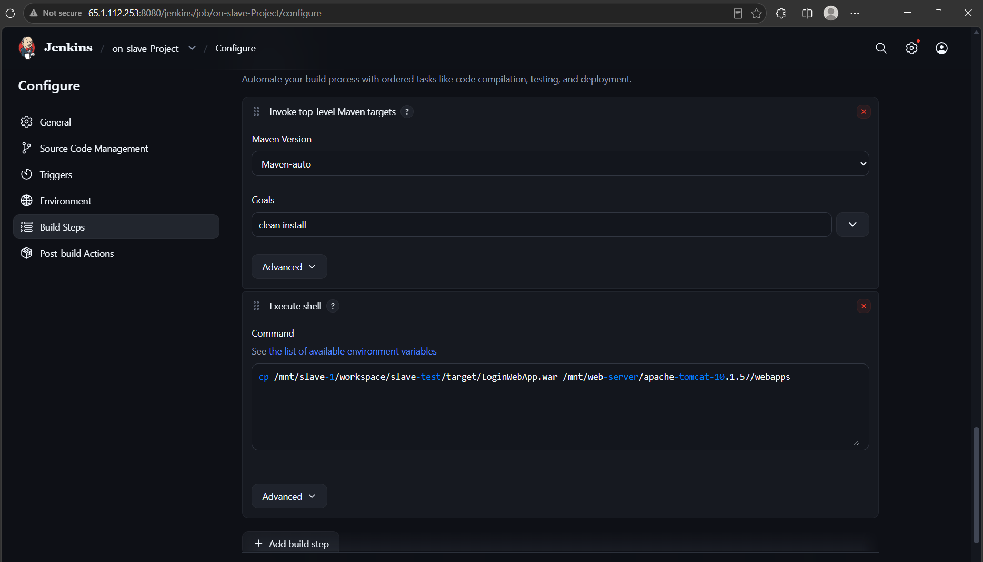
Build Successful
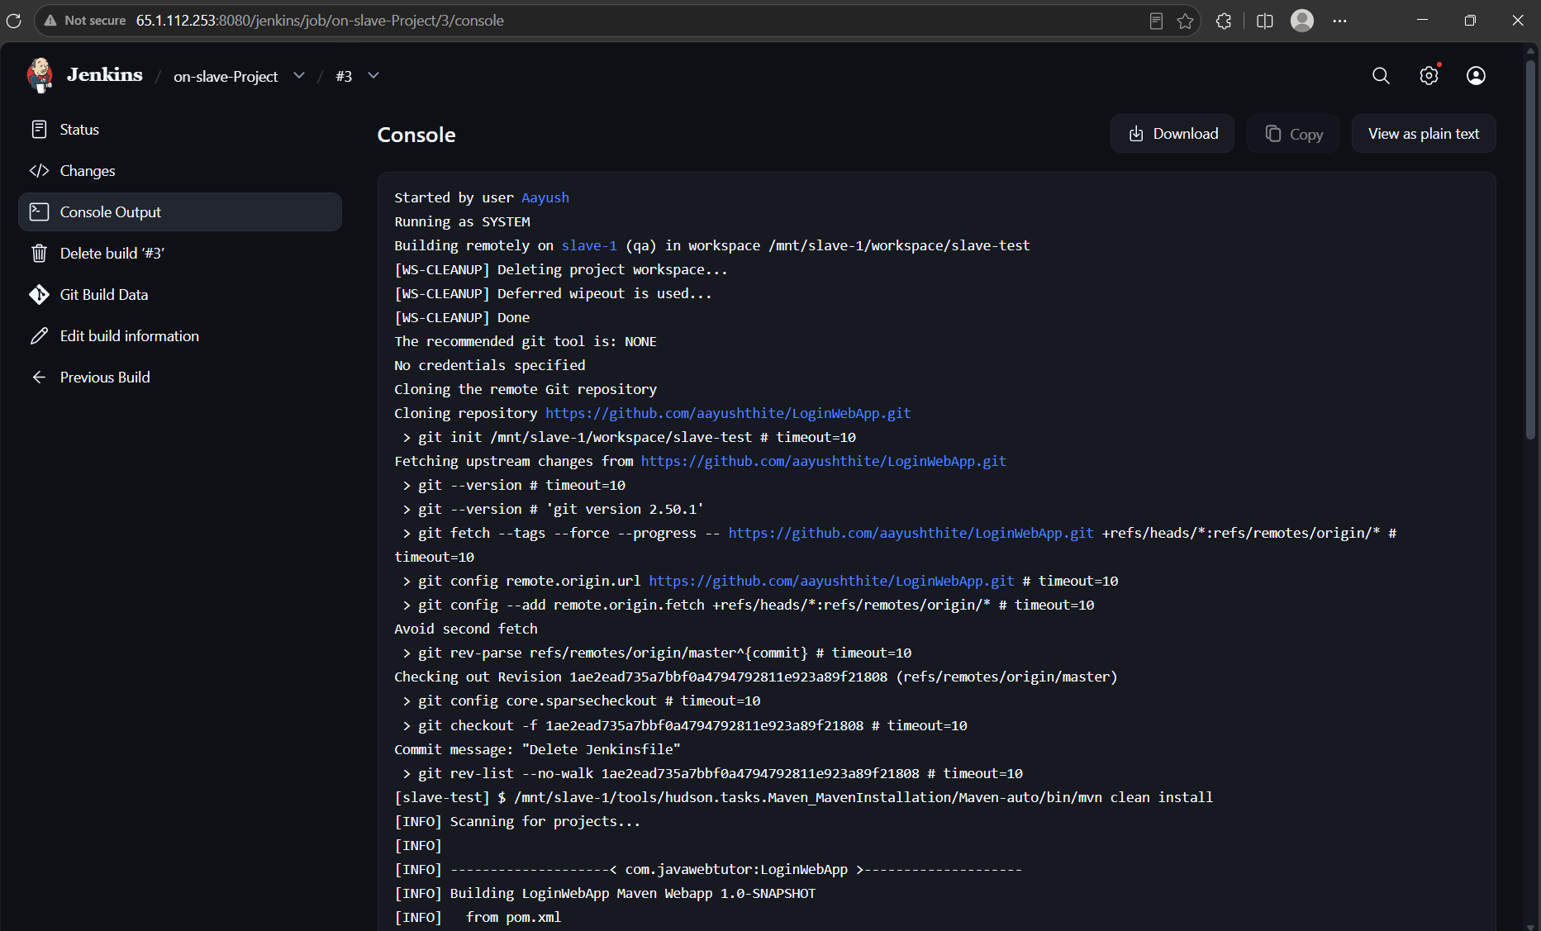
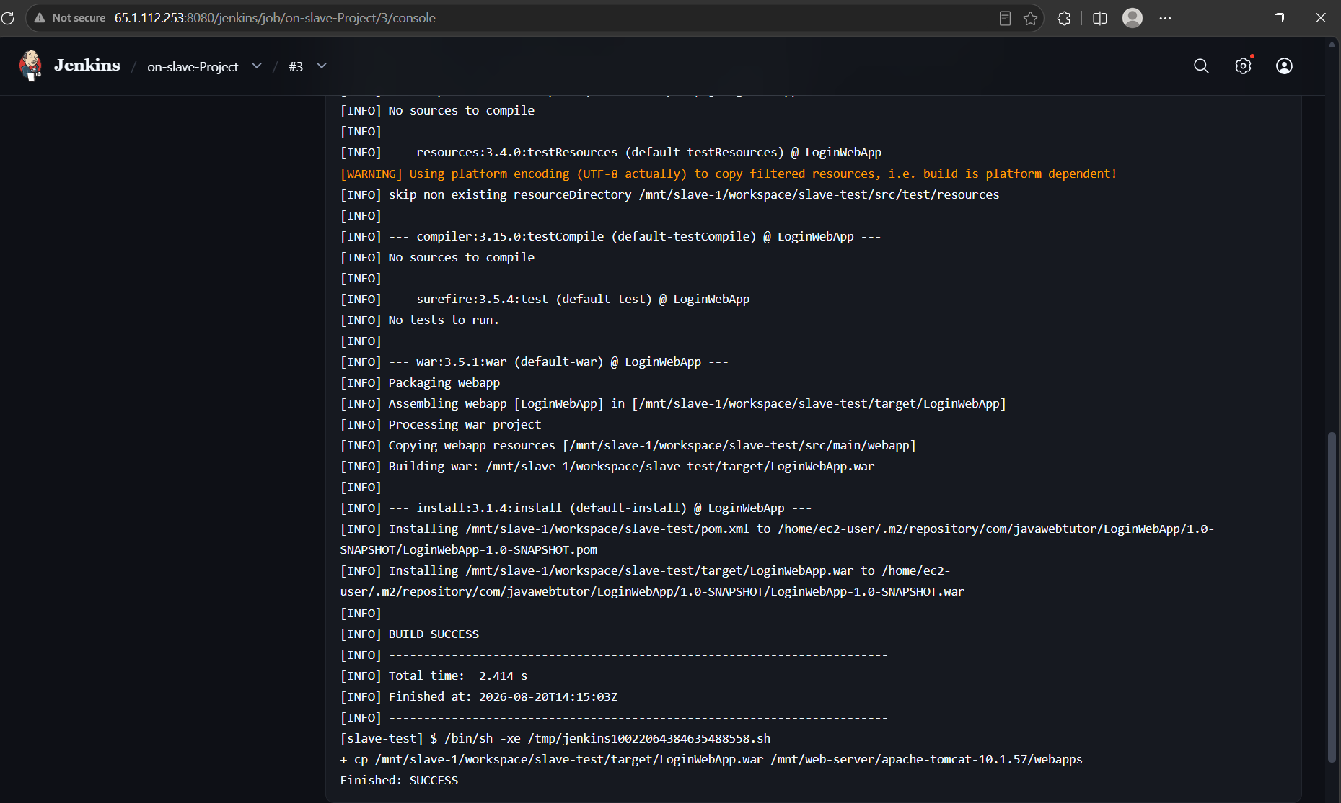
Now we can Successfully access the application
